A-1) Pyramid Principle Exercise (Football Dataset: Premier League 2025/26)

Liverpool is the current best team in the Premier League.

1. Liverpool boasts the most points (15) after 5 games, having won all of them.

2. They are the only untainted team yet, with a 100% winning record.

3. Their goal-scoring prowess (11 goals) coupled with a tight defense

(conceding just 5) promises balance and consistency.

* Liverpool sits atop the table with 5 victories from 5 matches, demonstrating superiority over every team.
* Arsenal, Tottenham, and Bournemouth all have 9 points, yet each has already lost 1 match and played fewer games.
* Arsenal boasts the best goal difference (+8) but fewer points (9), placing them below Liverpool in the table.
* Chelsea (8 points) are also unbeaten but have drawn 2 matches, so they lie behind even though they have scored 9 goals.
* Manchester City, being the team of last season which was dominating, has already lost 2 games and has only 6 points.

The table indicates Liverpool as the top performer with maximum points and a clean start. Although Arsenal and Tottenham have solid defenses (conceding only 1 goal each), their lost points via defeats restrict their ranking. Bournemouth and Chelsea are contenders but short of either goal difference or overall wins. Generally, Liverpool's balance of attack, defense, and consistency make them the best team at this stage of the season.

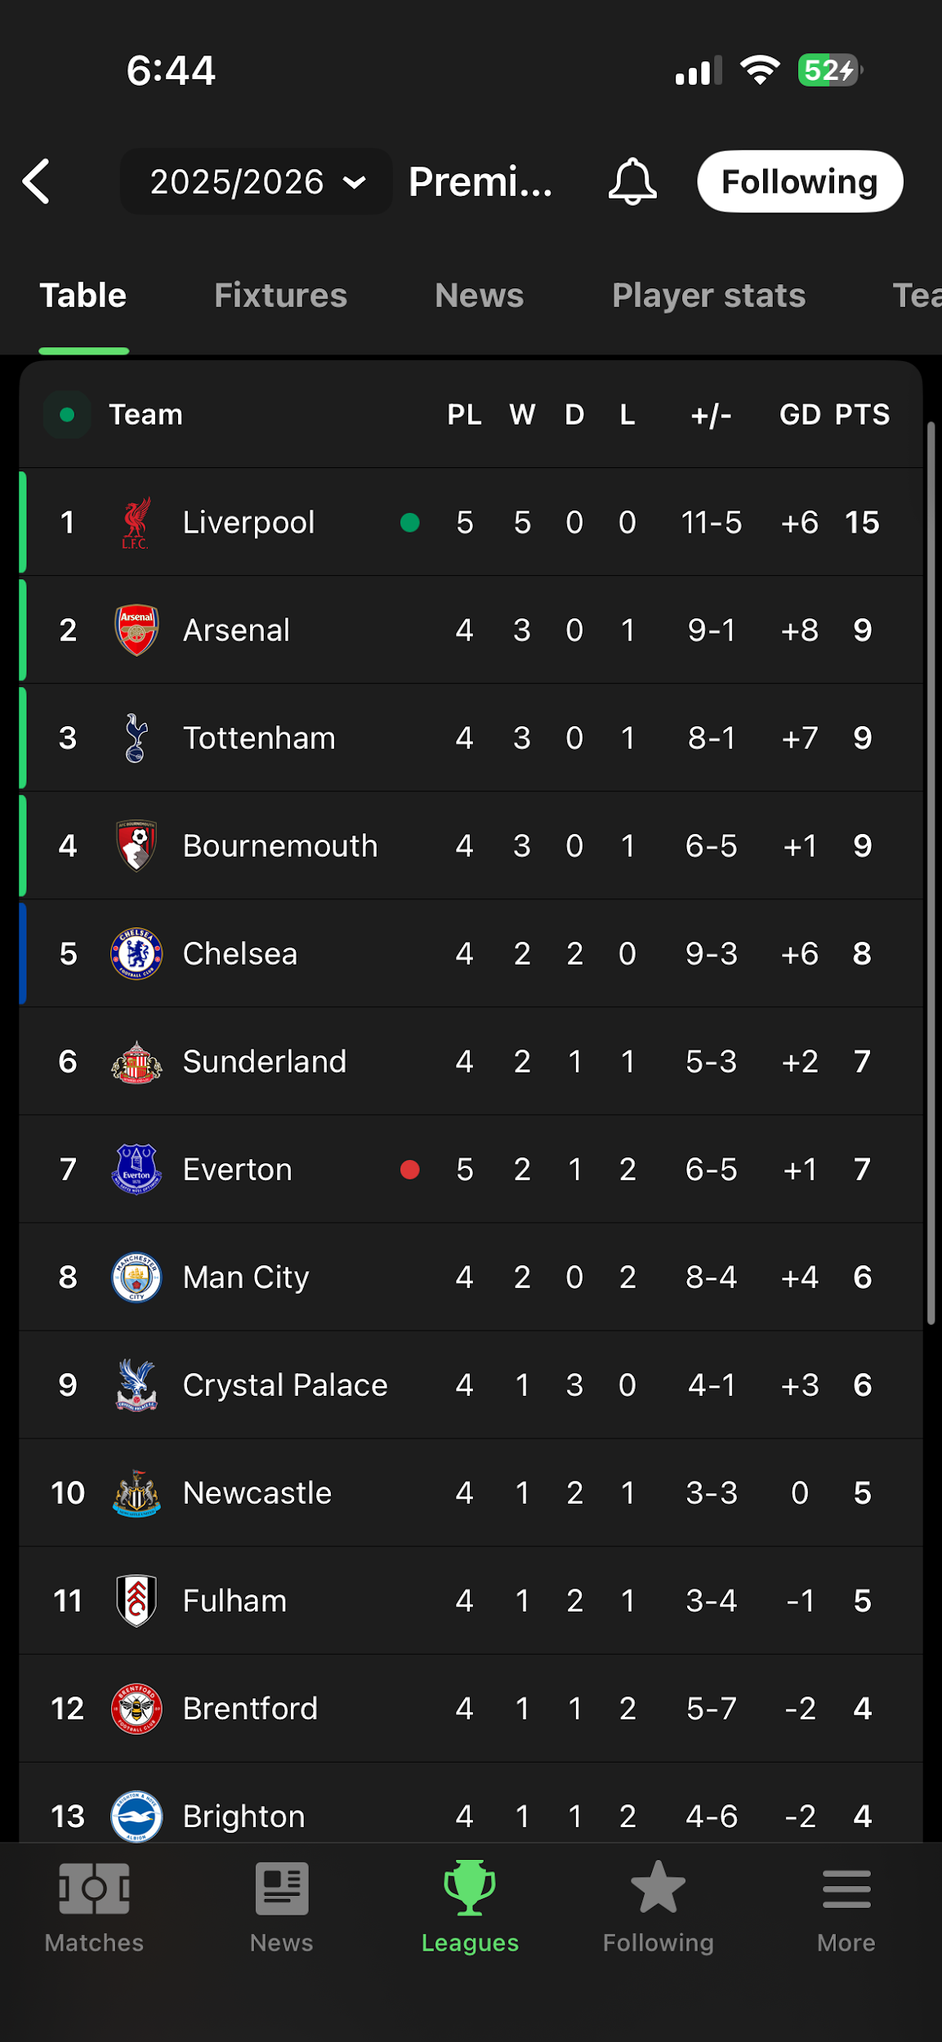

A-2) 7Cs of Communication Etiquette

Subject: Request for Q3 Updated Sales Data to be used in Q3 Analysis

Dear Manager,

Hope you are doing well. I am engaged in the quarterly performance dashboard and would want to request the updated sales data for Q3 (July–September 2025) in order to provide accurate data.

Particularly, I would require:

• Region-wise sales details

• Product-level details

• Customer acquisition figures

If feasible, please provide the dataset by 22nd September, so that I am able to finish the analysis on time and present timely insights for the management review meeting.

Let me know in case you need any clarifications on data requirements. Your support and cooperation are highly appreciated.

Best regards,

Aryan Pattni